Gabon Mahongwe Reliquary —20th Century   
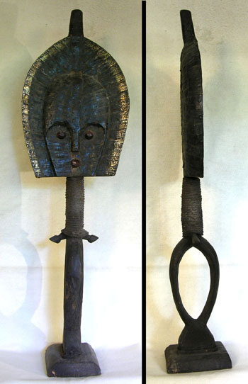  
Very large Mahongwe reliquary Bwete (or Bwitti) guardian figure. Mahongwe reliquary figures typically have large oval-shaped tapering heads which are covered by brass bands or wires and are overall highly abstract in style. Figures like these were mounted on or by containers holding relics of important clan ancestors, serving as guardians. They are sometimes danced with by new chiefs and dedicated to Bwitti, the spirit of the ancestors. The Mahongwe are a subgroup of the Bakota, and like them, used these figures as guardians of their ancestors. This example is unusually large, over three feet tall, with small rarely seen stylized arms just below the neck. The upper portion is completely covered front and back in layers of thin hammered brass. The elongated neck is wrapped in rope. An impressive example with a nice aged patina. Displays dramatically!   
  
Ex. private N.C. collection.   
  
40" tall x 12" across   
  
$750